**Creating Docker Image For Multiple IPFS Daemon Instances**

* DockerFile script to create a image with the go build :- 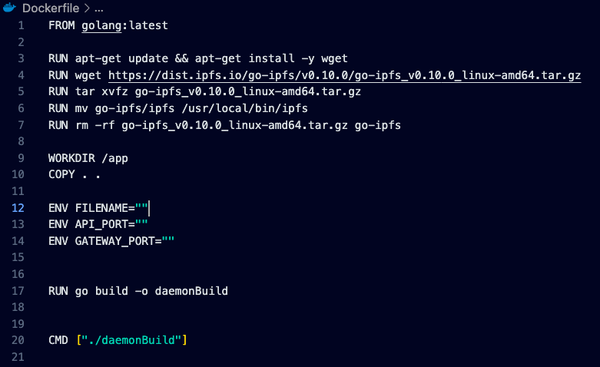
* Golang latest version will be installed from the first line of script and thereafter IPFS will be installed to the virtual environment of docker.
* The current directory where the docker file is situated is made as the actual working directory for the docker container.
* All the files present in that directory will be copied to the docker
* Here the “FILENAME”,”APIPORT”,”GATEWAY PORT” are taken as the environment variables which are needed to be parsed as arguments to run the docker image. Running image will be discussed in the next part.
* “**RUN go build -o daemonBuild**” it builds the go modules inside the docker environment.
* “**CMD[“./daemonBuild”]**” executes the built file in the docker

**Running the docker image from the command line :-**

* To run the docker image that is created the following command is used:-

**docker run --name "NameOfContainer" -e FILENAME="Filename" -e API_PORT="ApiPort" -e GATEWAY_PORT="GatewayPort" -tid daemonbuild-image1 /bin/bash**

* Filename ,Api Port and Gateway Port are taken as environmental variables and parsed as arguments in the command.
* Just execute “**go run .”** in the docker terminal and daemon starts running with the specified Api Port number.

**Note:** if another daemon instance is needed again above command can be executed with different ports and filename. A New container will be created and daemon can be runned.